

**CREATIVES**

**WEBSITE**

**Submitted By:**

Vedant Handa

2210990954 (

G

-

14

)

**Supervised By:**

RAVEESH SAMKARIA

|  |
| --- |
| **ABSTRACT**  The provided HTML code encapsulates the framework for a modern and dynamic website tailored for a creative agency. Comprising various sections meticulously crafted to engage and inform visitors, this website offers a comprehensive glimpse into the agency's offerings, ethos, and accomplishments. Leveraging a blend of captivating design elements, seamless navigation, and intuitive functionality, the website aims to captivate and retain user interest. External resources such as Font Awesome icons and CSS stylesheets enrich the visual appeal and user experience, ensuring a polished and professional presentation. Through strategic placement of sections like feature showcases, team introductions, blog previews, and contact forms, the website seeks to not only showcase the agency's expertise but also foster meaningful interactions with potential clients and collaborators. |
| **INTRODUCTION**  In the digital realm where first impressions are paramount, a well-designed website serves as the cornerstone of a brand's online identity.  The HTML code provided lays the groundwork for an immersive online experience tailored specifically for a creative agency. This introduction serves as the virtual gateway to the agency's world, inviting visitors to explore its array of services, meet the talented team behind the scenes, and delve into recent projects and insights. With an eye-catching design and user-centric approach, this website endeavors to not only inform but also captivate and inspire its audience. Through seamless navigation and visually striking elements, the website aims to establish a lasting connection with visitors, fostering trust and credibility in the agency's capabilities.  By setting the stage for meaningful interactions and engagement, this introduction sets the tone for a journey of exploration and discovery within the vibrant landscape of creativity and innovation |
| **OBJECTIVE**  This website seeks to achieve the following objectives:  1.Showcase the agency's creativity and proficiency in delivering digital solutions.  2.Provide comprehensive information about the agency's services, including features, extensions, and tutorials. 3.Introduce the agency's team members and their respective roles.  4.Present recent blog posts or projects to highlight the agency's capabilities and achievements.  5.Encourage interaction and communication by including a contact form for inquiries or project discussions.  6.Ensure responsiveness across various devices for a seamless user experience.  7.Establish a professional and credible online presence for the agency, enhancing its brand image and visibility.  By fulfilling these objectives, the website aims to attract potential clients, foster business partnerships, and ultimately contribute to the growth and success of the creative agency. |

**PROBLEM STATEMENT**

We were provided with the unique templates to design them

in same way .

Below are the screenshot of template provided to me .

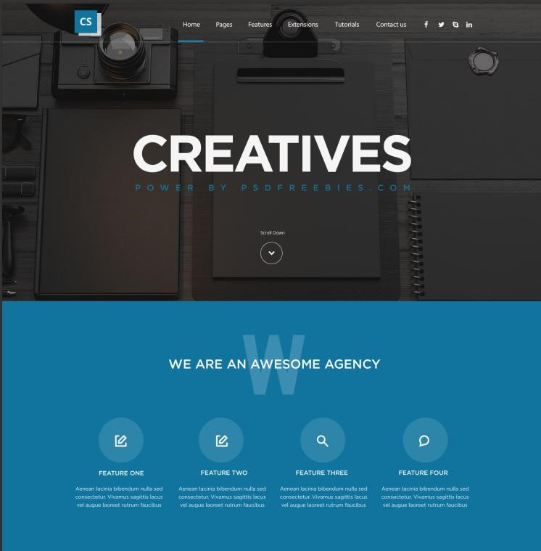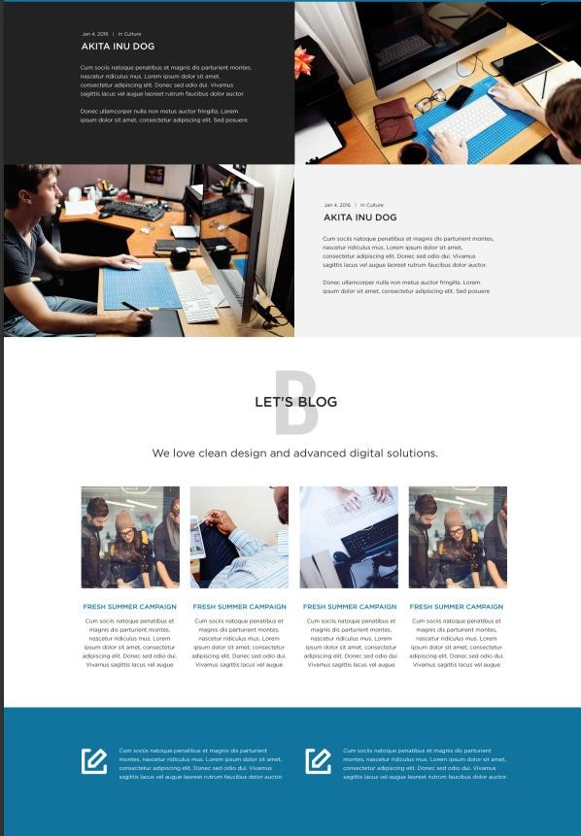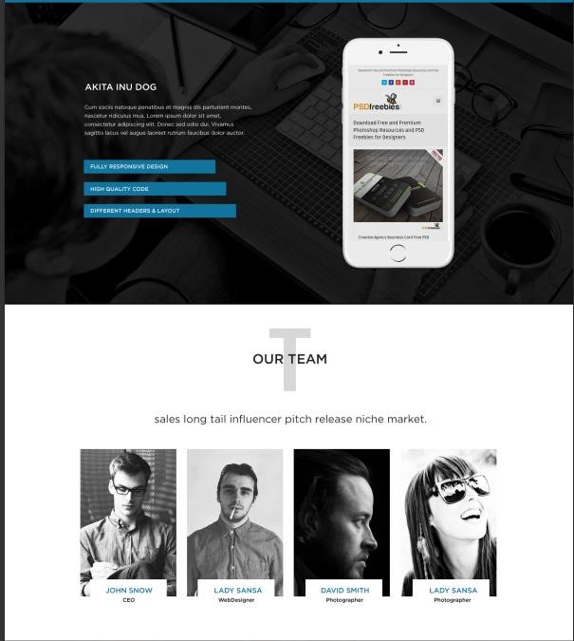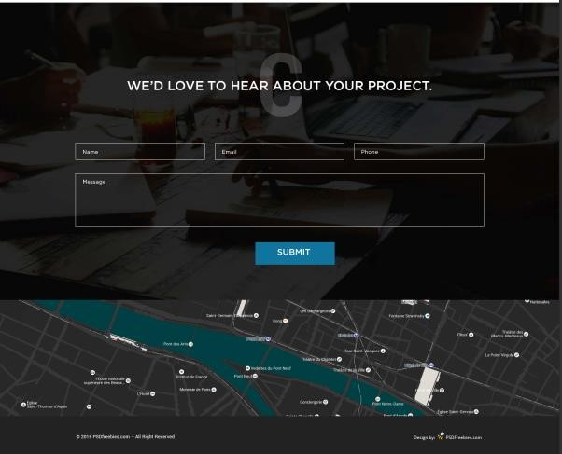

|  |
| --- |
| **REQUIREMENTS**  ***Software Requirements :***  **HTML**: HTML provides the fundamental structure for web pages, consisting of elements enclosed in tags, which define the content and layout.  HTML documents should adhere to standards and undergo  validation to ensure proper syntax, structure, and compatibility across different web browsers and device  **CSS**: CSS is used to define the presentation and layout of HTML elements on a web page, including aspects such as color, font, size, spacing, and positioning. CSS models elements on a web page as rectangular boxes, comprising content, padding, border, and margin. Developers can manipulate these box properties to control layout and spacing. |
| **METHODOLOGY**  ***HTML CODE*** :  <!DOCTYPE *html*>  <html *lang*="en">  <head>      <meta *charset*="UTF-8">      <meta *name*="viewport" *content*="width=device-width, initial-scale=1.0">      <title>Document</title>      <link *rel*="stylesheet" *href*="https://cdnjs.cloudflare.com/ajax/libs/font-awesome/6.5.1/css/all.min.css">      <link *rel*="stylesheet" *href*="https://cdnjs.cloudflare.com/ajax/libs/font-awesome/6.5.1/css/all.min.css">      <link *rel*="stylesheet" *href*="link rel="*stylesheet"* *href*="https://icono-49d6.kxcdn.com/icono.min.css">      <link *rel*="stylesheet" *href*="https://cdnjs.cloudflare.com/ajax/libs/font-awesome/6.5.1/css/solid.min.css">      <link *rel*="stylesheet" *href*="app.css">      <script *defer* *src*="app.js"></script>      <script *src*=""></script>  </head>  <body>      <section *id*="s1">          <div *class*="container">              <nav>                  <ul *id*="slidebar">                      <li *onclick*=hideSlidebar()><a *href*=""><img *src*="Logo.png" *alt*=""></a></li>                      <li><a *href*="">Home</a></li>                      <li><a *href*="#div2">Pages</a></li>                      <li><a *href*="">Features</a></li>                      <li><a *href*="">Extensions</a></li>                      <li><a *href*="">Tutorials</a></li>                      <li><a *href*="">Contact Us</a></li>                      <div *class*="socials">                      <a *href*=""><i *class*="fa-brands fa-facebook-f fa-lg" *style*="color: #f1f2f3;"></i></a>                      <a *href*=""><i *class*="fa-brands fa-twitter fa-lg" *style*="color: #f7f9fc;"></i></a>                      <a *href*=""><i *class*="fab fa-skype" *style*="color: #e9ecf1;"></i></a>                      <a *href*=""><i *class*="fa-brands fa-linkedin fa-lg" *style*="color: #eceff3;"></i></a>                    </ul>                    <ul>                      <li *class*="hideOnMobile"><img *src*="Logo.png" *alt*=""></li>                      <li *class*="hideOnMobile"><a *href*="">Home</a></li>                      <li *class*="hideOnMobile"><a *href*="#div2">Pages</a></li>                      <li *class*="hideOnMobile"><a *href*="">Features</a></li>                      <li *class*="hideOnMobile"><a *href*="">Extensions</a></li>                      <li *class*="hideOnMobile"><a *href*="">Tutorials</a></li>                      <li *class*="hideOnMobile"><a *href*="">Contact Us</a></li>                      <div *class*="socials">                      <a *class*="hideOnMobile" *href*=""><i *class*="fa-brands fa-facebook-f fa-lg" *style*="color: #f1f2f3;"></i></a>                      <a *class*="hideOnMobile" *href*=""><i *class*="fa-brands fa-twitter fa-lg" *style*="color: #f7f9fc;"></i></a>                      <a *class*="hideOnMobile" *href*=""><i *class*="fab fa-skype" *style*="color: #e9ecf1;"></i></a>                      <a *class*="hideOnMobile" *href*=""><i *class*="fa-brands fa-linkedin fa-lg" *style*="color: #eceff3;"></i></a>                      <li *class*="menuButton" *onclick*=showSlidebar()><svg *xmlns*="http://www.w3.org/2000/svg" *height*="29" *fill*="#FFFFFF"  *viewBox*="0 -960 960 960" *width*="29"><path *d*="M120-240v-80h720v80H120Zm0-200v-80h720v80H120Zm0-200v-80h720v80H120Z"/></svg></li>                    </ul>              </nav>              <div *class*="h1">              <h1 *id*="h1">Creatives</h1>              <h4 *id*="h4">POWER BY PSDFREEBIES . COM </h4>          </div>          <div *class*="circle">              <i *class*="fa-solid fa-down" *style*="color: #ffffff;"></i>          </div>            </div>          <div *class*="scroll-container">                <a *href*="#div2">                <svg *class*="scroll-icon" *xmlns*="http://www.w3.org/2000/svg" *viewBox*="0 0 24 24">                <path *d*="M12 14l-5.93-5.93a.996.996 0 0 0-1.41 0c-.39.39-.39 1.02 0 1.41L12 17.83l6.34-6.34c.39-.39.39-1.02 0-1.41s-1.02-.39-1.41 0L12 14z"/>              </svg>          </a>            </div>      </section>  <section *id*="s2">            <div *id*="div2">              <div *class*="big-w">W</div>              <div *id*="h2">                  <h1>We are An Awesome Agency</h1>              </div>  *<!-- <h1>We are An Awesome Agency</h1> -->*              <div *class*="features">                    <div *class*="feature12">                      <div *class*="search-container">                            <img *src*="Write.png" *alt*="">                          <path *d*="center"/>                          </svg>                      </div>                      <h2>Feature One</h2><br>                      <p>Lorem ipsum dolor sit amet consectetur, adipisicing elit. Consequuntur aut quasi id, tempora odio alias amet blanditiis veniam suscipit ipsa?</p>                  </div>                  <div *class*="feature1">                      <div *class*="search-container">                          <img *src*="Write.png" *alt*="">                          <path *d*="M15.5 14h-.79l-.28-.27a6.5 6.5 0 0 0 1.48-5.34c-.47-2.78-2.79-5-5.59-5.34a6.505 6.505 0 0 0-7.27 7.27c.34 2.8 2.56 5.12 5.34 5.59a6.5 6.5 0 0 0 5.34-1.48l.27.28v.79l5 4.99 1.42-1.42-4.99-5zm-6 0C7.01 14 5 11.99 5 9.5S7.01 5 9.5 5 14 7.01 14 9.5 11.99 14 9.5 14z"/>                          </svg>                      </div>                      <h2>Feature Two</h2><br>                      <p>Lorem ipsum dolor sit amet consectetur, adipisicing elit. Consequuntur aut quasi id, tempora odio alias amet blanditiis veniam suscipit ipsa?</p>                  </div>                  <div *class*="feature1">                      <div *class*="search-container">                          <svg *class*="search-icon" *xmlns*="http://www.w3.org/2000/svg" *viewBox*="0 0 24 24">                          <path *d*="M15.5 14h-.79l-.28-.27a6.5 6.5 0 0 0 1.48-5.34c-.47-2.78-2.79-5-5.59-5.34a6.505 6.505 0 0 0-7.27 7.27c.34 2.8 2.56 5.12 5.34 5.59a6.5 6.5 0 0 0 5.34-1.48l.27.28v.79l5 4.99 1.42-1.42-4.99-5zm-6 0C7.01 14 5 11.99 5 9.5S7.01 5 9.5 5 14 7.01 14 9.5 11.99 14 9.5 14z"/>                          </svg>                      </div>                      <h2>Feature Three</h2><br>                        <p>Lorem ipsum dolor sit amet consectetur, adipisicing elit. Consequuntur aut quasi id, tempora odio alias amet blanditiis veniam suscipit ipsa?</p>                  </div>                  <div *class*="feature1">                      <div *class*="search-container">                          <img *src*="Simon says.png" *alt*="">                          <path *d*="M15.5 14h-.79l-.28-.27a6.5 6.5 0 0 0 1.48-5.34c-.47-2.78-2.79-5-5.59-5.34a6.505 6.505 0 0 0-7.27 7.27c.34 2.8 2.56 5.12 5.34 5.59a6.5 6.5 0 0 0 5.34-1.48l.27.28v.79l5 4.99 1.42-1.42-4.99-5zm-6 0C7.01 14 5 11.99 5 9.5S7.01 5 9.5 5 14 7.01 14 9.5 11.99 14 9.5 14z"/>                          </svg>                        </div>                      <h2>Feature Four</h2><br>                      <p>Lorem ipsum dolor sit amet consectetur, adipisicing elit. Consequuntur aut quasi id, tempora odio alias amet blanditiis veniam suscipit ipsa?</p>                  </div>              </div>          </div>      </section>    *<!-- </section> -->*      <section *id*="s3">          <div *id*="div3">              <div *class*="square1">                  <p>Jan 4 2016 | In Culture</p>                  <h2>AKITA INU DOG</h2>                  <p *id*="text">Lorem ipsum dolor sit amet consectetur adipisicing elit. Non minus animi perspiciatis labore quaerat facilis recusandae explicabo asperiores impedit nihil?                      Lorem ipsum dolor sit amet consectetur adipisicing elit. Non minus animi perspiciatis labore quaerat facilis recusandae explicabo asperiores impedit nihil?                  </p>              </div>              <div *class*="square2">                </div>              <div *class*="square3">  *<!-- <img src="3.jpg" alt="img" id="pic3"> -->*              </div>              <div *class*="square4">                  <p>Jan 4 2016 | In Culture</p>                  <h2>AKITA INU DOG</h2>                  <p *id*="text">Lorem ipsum dolor sit amet consectetur adipisicing elit. Non minus animi perspiciatis labore quaerat facilis recusandae explicabo asperiores impedit nihil?                  Lorem ipsum dolor sit amet consectetur adipisicing elit. Non minus animi perspiciatis labore quaerat facilis recusandae explicabo asperiores impedit nihil?</p>              </div>          </div>      </section>      <section *id*="s4">          <div *id*="div1">          <div *class*="big-b">B</div>          <div *id*="h3">              <h1>Let's Blog</h1>          </div>          <div *id*="heading"><h1>We love clean design and advanced digital solutions.</h1></div>          <div *id*="blog1">              <img *src*="blog/Blog1/Layer 83.png" *alt*="">              <h3>Fresh Summer Campaign</h3>              <p>Lorem ipsum, dolor sit amet consectetur adipisicing elit. Velit placeat reprehenderit officiis corrupti non minima saepe. Distinctio excepturi voluptatibus vitae debitis incidunt, inventore, nesciunt atque, cum vero sapiente est veritatis iusto? Iste eaque illo, explicabo tempora nam odit nisi in.</p>          </div>          <div *id*="blog1">              <img *src*="blog/Blog2/Layer 84.png"*"*>              <h3>Fresh Summer Campaign</h3>              <p>Lorem ipsum, dolor sit amet consectetur adipisicing elit. Velit placeat reprehenderit officiis corrupti non minima saepe. Distinctio excepturi voluptatibus vitae debitis incidunt, inventore, nesciunt atque, cum vero sapiente est veritatis iusto? Iste eaque illo, explicabo tempora nam odit nisi in.</p>          </div>          <div *id*="blog1">              <img *src*="blog/Blog3/Layer 85.png" *alt*="">              <h3>Fresh Summer Campaign</h3>              <p>Lorem ipsum, dolor sit amet consectetur adipisicing elit. Velit placeat reprehenderit officiis corrupti non minima saepe. Distinctio excepturi voluptatibus vitae debitis incidunt, inventore, nesciunt atque, cum vero sapiente est veritatis iusto? Iste eaque illo, explicabo tempora nam odit nisi in.</p>          </div>          <div *id*="blog1">              <img *src*="blog/Blog1/Layer 83.png" *alt*="">              <h3>Fresh Summer Campaign</h3>              <p>Lorem ipsum, dolor sit amet consectetur adipisicing elit. Velit placeat reprehenderit officiis corrupti non minima saepe. Distinctio excepturi voluptatibus vitae debitis incidunt, inventore, nesciunt atque, cum vero sapiente est veritatis iusto? Iste eaque illo, explicabo tempora nam odit nisi in.</p>          </div>          </div>        </section>      <section *id*="s5">          <div *id*="background">              <div *class*="d1" *style*="width: 50%; height: 100%;"> <img *src*="quickAction/Write copy 2.png" *alt*="">                  <p>Lorem ipsum dolor sit amet, consectetur adipisicing elit. Pariatur laudantium doloremque cumque consectetur, distinctio delectus unde quo ex est error?</p>              </div>          <div *class*="d2" *style*="width: 50%; height: 100%; position: relative; left: 50%; bottom: 100%;">          <img *id*="image" *src*="quickAction/Write copy 2.png" *alt*="">              <p *id*="p2" *style*="position:relative; left: 30%;">Lorem ipsum dolor sit amet, consectetur adipisicing elit. Pariatur laudantium doloremque cumque consectetur, distinctio delectus unde quo ex est error?</p>          </div>        </section>      <section *id*="s6">          <div *id*="text_area">              <img *src*="textArea/Rectangle 1 copy.png" *alt*="">              <h1>AKITA INU DOG</h1>              <p>Lorem ipsum dolor sit amet consectetur adipisicing elit. Non minus animi perspiciatis labore quaerat facilis recusandae explicabo asperiores impedit nihil? Lorem ipsum dolor sit amet consectetur adipisicing elit. Non minus animi perspiciatis labore quaerat facilis recusandae explicabo asperiores impedit nihil?</p>              <h2 *class*="h12">Fully responsive design</h2>              <h2 *class*="h22">High quality code</h2>              <h2 *class*="h32">Diffrent headers & layout</h2>          </div>      </section>      <section *id*="s7">          <div *id*="team">              <div *class*="big_t">T</div>              <div *id*="h"><h1>Our Team</h1></div>              <div *id*="team_heading"><h1>sales long tail pitch release niche market.</h1></div>              <div *id*="team_member1">                  <img *src*="team/Layer 81.png" *alt*="">                  <div *id*="info"><h3>John Snow</h3>                  <h5>CEO</h5>                  </div>              </div>              <div *id*="team_member2">                  <img *src*="team/Layer 82.png" *alt*="">                  <div *id*="info2"><h3>Lady Sansa</h3>                  <h5>WebDesigner</h5>                  </div>              </div>              <div *id*="team_member3">                  <img *src*="team/Layer 93.png" *alt*="">                  <div *id*="info3"><h3>David Smith</h3>                  <h5>Photographer</h5>                  </div>              </div>              <div *id*="team_member4">                  <img *src*="team/Layer 94.png" *alt*="">                  <div *id*="info4"><h3>Lady Sansa</h3>                  <h5>Photographer</h5>                  </div>                </div>          </div>      </section>      <section *id*="s8">          <div *id*="inform">              <div *class*="big-c">C</div>              <div *id*="headi"><h1>We'd Love to hear about your Project</h1></div>              <form *id*="Submit">                  <input *type*="text" *placeholder*="Name" *id*="name">                  <input *type*="text" *placeholder*="Email" *name*="" *id*="email">                  <input *type*="text" *placeholder*="Phone Number" *id*="phone">                  <input  *placeholder*="Message" *id*="Message">                  <button *id*="submit2" *style*="height: 50px; width: 120px; position: relative; left: 47%; top: 15rem; background-color: #11749E; color: white; font-family: Arial, Helvetica, sans-serif; text-transform: uppercase; font-size: large; font-weight: lighter;">                      Submit</button>              </form>          </div>      </section>      <section *id*="s9">          <div *id*="Map">              <img *src*="map/Layer 98.png" *alt*="">          </div>      </section>      <section *id*="s10">          <div *id*="footer">              <h3>2016 PSDfreebies.com - All Rights Reserved</h3>              <img *src*="footer.png" *alt*="">          </div>      </section>  </body>  </html> |

***CSS CODE :***

*{

    margin: 0;

    padding: 0;

}

*.container*{

*/* background-image: url("https://img.freepik.com/free-photo/flat-lay-camera-black-background-with-copy-space_23-2148363419.jpg?t=st=1706626378~exp=1706626978~hmac=e4fa074305f5e75a79f96eae3388a45f561d2c4273fbe1e8344ce8f668b91e69"); */*

    background-image: url("Layer\ 96.png");

    background-repeat: no-repeat;

    background-size: cover;

    height: 900px;

}

html{

    scroll-behavior: smooth;

}

body{

    overflow-x: hidden;

}

nav img{

    height: 50px;

    width: 50px;

}

nav ul li a{

    text-decoration: none;

    color: white;

}

nav ul li a*:hover*{

    border-bottom: 5px solid #11749E;

}

nav ul{

    display: flex;

    justify-content: center;

    align-items: center;

}

nav li{

    padding-left: 50px;

    list-style: none;

    padding-top: 20px;

    margin-bottom: 10px;

}

nav {

    width: 100%;

    border-bottom: 2px solid gray;

    animation: scrollAnimation 0.5s ease-in-out forwards;

}

*#slidebar* {

    position: fixed;

    top: 0;

    right: 0;

    height: 100vh;

    width: 250px;

    z-index: 999;

    background-color: #3c3c3b2f;

    backdrop-filter: blur(10px);

    display: none;

    flex-direction: column;

    align-items: flex-start;

    justify-content: flex-start;

}

*#slidebar* li{

    width: 100%;

}

*#slidebar* a{

    width: 100%;

}

*.menuButton*{

    display: none;

}

*#h1*{

    color: white;

    text-align: center;

    font-size: 8rem;

    text-transform: uppercase;

    font-family: Arial, Helvetica, sans-serif;

    animation: fade-down 0.5s;

    animation: scrollAnimation 0.5s ease-in-out forwards;

}

*.h1*{

    display: block;

    padding-top: 10%;

}

*#h2* h1{

    text-transform: uppercase;

    font-family: Arial, Helvetica, sans-serif;

}

*#h2* h1{

    color: white;

    position:absolute;

    left: 30%;

    bottom: 37rem;

    font-size: 3rem;

}

*#h4*{

    color:#11749E;

    text-align: center;

    font-size: 1rem;

    text-transform: uppercase;

    font-family: Arial, Helvetica, sans-serif;

}

*.h4*{

    display: block;

    padding-top: 10%;

}

*#h2* h4{

    text-transform: uppercase;

    font-family: Arial, Helvetica, sans-serif;

}

*#h2* h4{

    color:#11749E;

    position: absolute;

    left: 30%;

    bottom: 33rem;

    font-size: 3rem;

}

*.fa-down*{

    z-index: 1;

}

*.circle*{

    z-index: 1;

}

*#div2*{

    background-color: #11749E;

    display: flex;

    justify-content: center;

    align-items: center;

    position: relative;

*/* top: 320px; */*

    top: -73px;

    height: 100vh;

}

*.features*{

    display: flex;

    position: relative;

    width: 70%;

    right: 0%;

    padding-top: 100px;

*/* opacity: 0;*

*filter: blur(5px);*

*transform: translateX(-100%);*

*transition: all 1s; */*

}

*.feature1*{

    padding-left: 50px;

    width: 40%;

    padding-top: 40px;

*/* opacity: 1;*

*filter: blur(0);*

*transform: translateX(0); */*

}

*.feature12*{

    padding-left: 50px;

    width: 40%;

    padding-top: 40px;

*/* opacity: 0;*

*filter: blur(5px);*

*transform: translateX(-100%);*

*transition: all 1s;*/*

*/* opacity: 1;*

*filter: blur(0);*

*transform: translateX(0); */*

}

p{

    width: 60%;

}

*.features* h2,p{

    color: white;

}

*.srch*{

    background-color: red;

    border-radius: 50%;

    width: 50px;

}

*.search-container* {

    width: 80px;

    height: 80px;

    border-radius: 50%;

    background-color: #2E85AA;

    display: flex;

    justify-content: center;

    align-items: center;

  }

*.search-icon* {

    width: 30px;

    height: 30px;

    fill: #fff; */* Change the color of the search icon as needed */*

  }

*.feature1* h2{

    padding-top: 20px;

}

*.big-w* {

    font-size: 11rem; */* Adjust the font size as needed */*

    font-weight: bold;

    position: relative;

    left: 35%;

    font-family: Arial, Helvetica, sans-serif;

    bottom: 33%;

    color: #3C8DAF; */* Change the color of the W as needed */*

    animation: scrollAnimation 0.5s ease-in-out forwards;

}

*.scroll-container* {

    width: 70px;

    height: 70px;

    border-radius: 50%;

    border: 2px solid white;

    background-color: transparent; */* Circular background color */*

    display: flex;

    justify-content: center;

    align-items: center;

    position: relative;

    left: 46%;

    bottom: 300px;

    z-index: 1;

  }

*.scroll-icon* {

    width: 30px;

    height: 30px;

    position: relative;

    fill: #fff; */* Color of the scroll icon */*

  }

*.socials*{

    display: flex;

    position: relative;

    left: 10%;

}

*.socials* a{

padding-left: 20px;

left: 20px;

}

*#div3*{

    display: grid;

    position: relative;

    top: -73px;

    grid-template-columns: repeat(2,4fr);

}

*.square1*{

    width:100%;

    background-color: black;

    height: 350px;

}

*.square1* p{

    color: white;

    text-align: center;

    padding-top: 50px;

}

*.square1* h2{

    color: white;

    text-align: center;

    padding-top: 0px;

    padding-right:320px;

}

*#text*{

    width: 40%;

    padding-left: 150px;

    padding-top: 3px;

    text-align: left;

}

*.square2*{

    background-image: url("newsAgency1/Layer\ 88.png");

}

*#pic3*{

    width: 100%;

    height: 350px;

}

*.square4*{

    width:100%;

    background-color: white;

    height: 350px;

}

*.square4* p{

    color: black;

    text-align: center;

    padding-top: 50px;

}

*.square4* h2{

    color: black;

    text-align: center;

    padding-top: 0px;

    padding-right:320px;

}

*.square3*{

    background-image: url("newsAgency2/Layer\ 90.png");

}

*.big-b* {

    font-size: 16rem;

    font-weight: bolder;

    position:absolute;

    left: 48%;

    font-family:'Franklin Gothic Medium', 'Arial Narrow', Arial, sans-serif;

    bottom: 61%;

    color: #C7C8CC;

    font-stretch: condensed;

    animation: scrollAnimation 0.5s ease-in-out forwards;

}

*#div1*{

    background-color: white;

    display: flex;

    justify-content: center;

    align-items: center;

    position: relative;

*/* top: 320px; */*

    top: -73px;

    height: 100vh;

}

*#h3* h1{

    text-transform: uppercase;

    font-family: Arial, Helvetica, sans-serif;

}

*#h3* h1{

    color: black;

    position:absolute;

    left: 47%;

    bottom: 35rem;

    font-size: 2rem;

}

*#heading* h1{

    position: absolute;

    font-family:sans-serif;

    font-weight:lighter;

    font-size: 2rem;

    bottom: 26rem;

    left:30%;

}

*#blog1* h3{

    font-family: 'Gill Sans', 'Gill Sans MT', Calibri, 'Trebuchet MS', sans-serif;

    font-weight: lighter;

    color:#11749E;

}

*#blog1* img{

    height: 250px;

    width: 250px;

}

*#blog1* p{

    font-family:'Gill Sans', 'Gill Sans MT', Calibri, 'Trebuchet MS', sans-serif ;

    font-weight: lighter;

    color: black;

    text-align: left;

    height: 300px;

    width: 300px;

}

*#blog1*{

    position: relative;

    left:3%;

    top:40%;

}

*#background*{

    background-image: url("quickAction/Rectangle\ 4\ copy\ 3.png");

    height: 300px;

}

*#background* img{

    position: relative;

    left: 20%;

    top: 49%;

}

*#background* p{

    height: 30px;

    width: 450px;

    position:relative;

    left: 33%;

    bottom: 40%;

    top: 30%;

}

*#p2* p{

    height: 30px;

    width: 450px;

}

*#text_area*{

    background-image: url("textArea/Layer\ 87.png");

    background-repeat: no-repeat;

    background-size: cover;

    height: 900px;

}

*#text_area* img{

    position: relative;

    left: 63%;

    top: 14%;

    animation: scrollAnimation 0.5s ease-in-out forwards;

}

*#text_area* h1{

    color: #fff;

    font-family: 'Gill Sans', 'Gill Sans MT', Calibri, 'Trebuchet MS', sans-serif;

    font-weight: lighter;

    position: relative;

    left: 21%;

    bottom: 40%;

}

*#text_area* p{

    height: 100px;

    font-family: 'Gill Sans', 'Gill Sans MT', Calibri, 'Trebuchet MS', sans-serif;

    font-weight: lighter;

    width: 390px;

    position: relative;

    left: 21%;

    bottom: 37%;

}

*.h12*{

    color: #fff;

    background-color: #2E85AA;

    height: 30px;

    width: 350px;

    padding-top: 10px;

    padding-left: 15px;

    font-size: 1rem;

    font-family: 'Gill Sans', 'Gill Sans MT', Calibri, 'Trebuchet MS', sans-serif;

    font-weight: lighter;

    text-transform: uppercase;

    text-align: left;

    position: relative;

    left: 21%;

    bottom: 29%;

}

*.h22*{

    color: #fff;

    background-color: #2E85AA;

    height: 30px;

    width: 380px;

    padding-top: 10px;

    padding-left: 15px;

    font-size: 1rem;

    font-family: 'Gill Sans', 'Gill Sans MT', Calibri, 'Trebuchet MS', sans-serif;

    font-weight: lighter;

    text-transform: uppercase;

    text-align: left;

    position: relative;

    left: 21%;

    bottom: 27%;

}

*.h32*{

    color: #fff;

    background-color: #2E85AA;

    height: 30px;

    width: 410px;

    padding-top: 10px;

    padding-left: 15px;

    font-size: 1rem;

    font-family: 'Gill Sans', 'Gill Sans MT', Calibri, 'Trebuchet MS', sans-serif;

    font-weight: lighter;

    text-transform: uppercase;

    text-align: left;

    position: relative;

    left: 21%;

    bottom: 25%;

}

*#team*{

    background-color: white;

    display: flex;

    justify-content: center;

    align-items: center;

    position: relative;

*/* top: 320px; */*

    top: -73px;

    height: 100vh;

}

*.big_t* {

    font-size: 14rem;

    font-weight: bolder;

    position:absolute;

    left: 48%;

    font-family:'Franklin Gothic Medium', 'Arial Narrow', Arial, sans-serif;

    bottom: 61%;

    color: #C7C8CC;

    font-stretch: condensed;

    animation: scrollAnimation 0.5s ease-in-out forwards;

}

*#h* h1{

    text-transform: uppercase;

    font-family: Arial, Helvetica, sans-serif;

}

*#h* h1{

    color: black;

    position:absolute;

    left: 45%;

    bottom: 34rem;

    font-size: 2rem;

}

*#team_member1* img{

    height: 350px;

    width: 250px;

    position: relative;

    right: 27rem;

    top: 13rem;

}

*#info*{

    background-color: #fff;

    height: 70px;

    width: 180px;

    position: relative;

    right: 25rem;

    top: 10rem;

    text-align: center;

    padding-top: 10px;

}

*#info* h3{

    margin-bottom: 2px;

    font-family: Arial, Helvetica, sans-serif;

    text-transform: uppercase;

    font-weight:bold;

    color:#11749E;

    font-stretch:wider;

}

*#info* h5{

    font-family: Arial, Helvetica, sans-serif;

    text-transform: uppercase;

    font-weight:bold;

    font-size:14px;

    color:black;

}

*#team_member2* img{

    height: 350px;

    width: 250px;

    position: relative;

    right: 23rem;

    top: 13rem;

}

*#info2*{

    background-color: #fff;

    height: 70px;

    width: 180px;

    position: relative;

    right: 21rem;

    top: 10rem;

    text-align: center;

    padding-top: 10px;

}

*#info2* h3{

    margin-bottom: 2px;

    font-family: Arial, Helvetica, sans-serif;

    text-transform: uppercase;

    font-weight:bold;

    color:#11749E;

    font-stretch:wider;

}

*#info2* h5{

    font-family: Arial, Helvetica, sans-serif;

    font-weight:bold;

    font-size:14px;

    color:black;

}

*#team_member3* img{

    height: 350px;

    width: 250px;

    position: relative;

    right: 19rem;

    top: 13rem;

}

*#info3*{

    background-color: #fff;

    height: 70px;

    width: 180px;

    position: relative;

    right: 17rem;

    top: 10rem;

    text-align: center;

    padding-top: 10px;

}

*#info3* h3{

    margin-bottom: 2px;

    font-family: Arial, Helvetica, sans-serif;

    text-transform: uppercase;

    font-weight:bold;

    color:#11749E;

    font-stretch:wider;

}

*#info3* h5{

    font-family: Arial, Helvetica, sans-serif;

    font-weight:bold;

    font-size:14px;

    color:black;

}

*#team_member4* img{

    height: 350px;

    width: 250px;

    position: relative;

    right: 16rem;

    top: 13rem;

}

*#info4*{

    background-color: #fff;

    height: 70px;

    width: 180px;

    position: relative;

    right: 14rem;

    top: 10rem;

    text-align: center;

    padding-top: 10px;

}

*#info4* h3{

    margin-bottom: 2px;

    font-family: Arial, Helvetica, sans-serif;

    text-transform: uppercase;

    font-weight:bold;

    color:#11749E;

    font-stretch:wider;

}

*#info4* h5{

    font-family: Arial, Helvetica, sans-serif;

    font-weight:bold;

    font-size:14px;

    color:black;

}

*#team*{

    padding-left: 690px;

}

*#team_heading* h1{

    position: absolute;

    font-family:sans-serif;

    font-weight:lighter;

    font-size: 2rem;

    bottom: 26rem;

    left:30%;

}

*#inform*{

    background-image: url("backGrounds/Layer\ 97.png");

    background-repeat: no-repeat;

    background-size: cover;

    height: 900px;

}

*.big-c* {

    font-size: 14rem; */* Adjust the font size as needed */*

    font-weight:10px;

    position: relative;

    font-stretch:condensed;

    left: 47%;

    font-family:Impact, Haettenschweiler, 'Arial Narrow Bold', sans-serif;

    bottom: -10%;

    color:#42433E;

    width: 120px;

    animation: scrollAnimation 0.5s ease-in-out forwards;

}

*#headi* {

    color: #fff;

    font-family: Arial, Helvetica, sans-serif;

    text-transform: uppercase;

    position: relative;

    left: 33%;

    bottom:6%;

    border: black;

    width: 550px;

}

*#name*{

    background-color: transparent;

    font-family: Arial, Helvetica, sans-serif;

    font-size: larger;

    color: #fff;

    height: 40px;

    width: 250px;

    position: relative;

    left: 22%;

    top: 1rem;

}

*#email*{

    background-color: transparent;

    font-family: Arial, Helvetica, sans-serif;

    font-size: larger;

    color: #fff;

    height: 40px;

    width: 250px;

    position: relative;

    left: 24%;

    top: 1rem;

}

*#phone*{

    background-color: transparent;

    font-family: Arial, Helvetica, sans-serif;

    font-size: larger;

    color: #fff;

    height: 40px;

    width: 250px;

    position: relative;

    left: 26%;

    top: 1rem;

}

*#Message*{

    background-color: transparent;

    text-align: left;

    font-family: Arial, Helvetica, sans-serif;

    font-size: larger;

    color: #fff;

    height: 250px;

    width: 700px;

    position: relative;

    left: -28%;

    top: 12rem;

}

*#Map*{

    position: relative;

    top: 10%;

}

*#Map* img{

    width: 1535px;

    height: 500px;

    position: relative;

    top: 10%;

}

*#footer*{

    height: 107px;

    background-color: black;

    position: relative;

    top: -4px;

}

*#footer* h3{

    color: #fff;

    font-family: Arial, Helvetica, sans-serif;

    font-size: small;

    position: relative;

    left: 6%;

    top: 40%;

}

*#footer* img{

    position: relative;

    left: 80%;

    top: 15%;

    height: 30px;

}

@media screen and (max-width: 768px) {

    nav img {

        height: 40px; */* Reduce image height for smaller screens */*

        width: 40px; */* Reduce image width for smaller screens */*

    }

    nav ul {

        flex-direction:column ; */* Stack menu items vertically */*

        align-items: left; */* Center items vertically */*

    }

    nav ul li {

        margin: 5px 0; */* Add vertical spacing between stacked menu items */*

    }

*.hideOnMobile*{

        display: none;

    }

*.menuButton*{

        display: block;

    }

*#h1* {

        font-size: 5rem; */* Adjusted for smaller screens */*

    }

*#h2* h1,

*#h2* h4 {

        font-size: 20px; */* Adjusted for smaller screens */*

    }

*#h2* h1 {

        bottom: 29rem; */* Adjusted for smaller screens */*

        left: 7rem;

    }

*#h2* h4 {

        bottom: 20rem; */* Adjusted for smaller screens */*

    }

*.features* {

        width: 50%; */* Reduce width for smaller screens */*

        padding:10px ; */* Adjusted padding for spacing */*

        margin-bottom: 12px; */* Adjusted spacing between features */*

        height: 44%;

        right: 30%;

    }

*.feature1*, *.feature2* {

        padding: 15px; */* Adjusted padding for spacing */*

    }

*.socials* {

        justify-content: center; */* Center social icons */*

    }

*.big-w* {

        font-size: 7rem; */* Increase font size for larger screens */*

        position: absolute; */* Position absolutely */*

        top: 27%; */* Center vertically */*

        left: 50%; */* Center horizontally */*

        transform: translate(-50%, -50%); */* Center both horizontally and vertically */*

    }

*#div3* {

        grid-template-columns: 1fr; */* Change to single column layout for smaller screens */*

    }

*.square1*, *.square2*, *.square3*, *.square4* {

        width: 100%; */* Full width for single column layout */*

        margin-bottom: 20px; */* Added margin between grid items */*

    }

*.square1* h2, *.square4* h2 {

        padding-right: 0; */* Remove right padding for headings on smaller screens */*

    }

*#text* {

        width: 80%; */* Adjusted width for smaller screens */*

        padding-left: 20px; */* Adjusted padding for smaller screens */*

        padding-top: 20px; */* Adjusted padding for smaller screens */*

    }

*.big-b* {

        font-size: 8rem; */* Adjusted font size for smaller screens */*

        left: 45%; */* Adjusted position for smaller screens */*

        bottom: 106%; */* Adjusted position for smaller screens */*

    }

*#div1* {

        height: auto; */* Adjusted height for smaller screens */*

    }

*#h3* h1 {

        bottom: 30.5rem; */* Adjusted position for smaller screens */*

        left: 33.5%;

    }

*#heading* h1 {

        bottom: 26rem; */* Adjusted position for smaller screens */*

        font-size: 21px;

        left: 10%;

    }

*#blog1*, *#background* {

        left: 5%; */* Adjusted position for smaller screens */*

        width: 90%; */* Adjusted width for smaller screens */*

    }

*#background* img {

        left: 10%; */* Adjusted position for smaller screens */*

    }

*#background* p, *#text_area* p {

        width: 90%; */* Adjusted width for smaller screens */*

        left: 5%; */* Adjusted position for smaller screens */*

        bottom: auto; */* Remove bottom position for smaller screens */*

    }

*#blog1* img,

*#blog2* img,

*#blog3* img,

*#blog4* img,

*#background* img,

*#text_area* img {

        width: 70%; */* Adjust width to fill the container */*

        height: 30%;

    }

*#blog1* p,

*#blog2* p,

*#blog3* p,

*#blog4* p,

*#background* p,

*#text_area* p {

        width: 70%; */* Set paragraph width to fill the container */*

        height: 40%;

        bottom: 40%;

        font-size: 12px;

    }

*#background* {

        background-size: 100%; */* Ensure background image covers the entire container */*

        height: auto; */* Allow background container height to adjust based on content */*

        padding: 20px; */* Add padding for better spacing */*

        text-align: center; */* Center-align content */*

    }

*#background* img {

        left: 40%; */* Center horizontally */*

        transform: translateX(-50%); */* Center using transform */*

        top: 50%; */* Center vertically */*

        margin-top: 20px; */* Add margin for better spacing */*

        height: 50px;

        width: 70px;

    }

*#background* p {

        width: 100%; */* Make paragraph width 100% */*

        max-width: 90%; */* Limit maximum width to maintain readability */*

        margin: 20px auto; */* Center horizontally and add margin for better spacing */*

        position: static; */* Reset positioning */*

        bottom: auto; */* Reset bottom positioning */*

        left: auto; */* Reset left positioning */*

        right: auto; */* Reset right positioning */*

        top: auto; */* Reset top positioning */*

    }

*#text_area* {

        height: auto; */* Allow container height to adjust based on content */*

        padding: 20px; */* Add some padding for better spacing */*

    }

*#text_area* img {

        display: block; */* Ensure the image is displayed as a block */*

        margin: 0 auto; */* Center the image horizontally */*

        max-width: 70%; */* Make the image responsive */*

        height: auto; */* Ensure aspect ratio is maintained */*

        margin-bottom: 20px; */* Add some space below the image */*

        left: 10rem;

    }

*#text_area* h1 {

        text-align: left; */* Center-align the heading */*

        margin-bottom: 20px; */* Add some space below the heading */*

        top: -20rem;

        left: 1rem;

    }

*#text_area* p {

        font-size: 14px; */* Reduce font size for better readability */*

        line-height: 1.5; */* Improve line spacing for readability */*

        text-align: left; */* Justify-align paragraphs */*

        margin-bottom: 20px; */* Add some space below paragraphs */*

        top: -20rem;

        width: 50%;

    }

*.h12*,

*.h22*,

*.h32* {

        width: 57%; */* Ensure full width for header elements */*

        height: 20%;

        text-align: left; */* Center-align header elements */*

        padding: 10px; */* Add some padding for better spacing */*

        margin-bottom: 10px; */* Add some space below headers */*

        top: -15rem;

        left: 1rem;

    }

*#team* {

        padding-left: 0; */* Remove padding to center team section */*

        text-align: center; */* Center-align the content */*

    }

*.big_t* {

        font-size: 8rem; */* Adjust heading font size */*

        bottom: 55%; */* Adjust heading position */*

    }

*#team_member1* img,

*#team_member2* img,

*#team_member3* img,

*#team_member4* img {

        width: 100px; */* Adjust image width */*

        height: auto; */* Ensure aspect ratio is maintained */*

        margin-bottom: 20px; */* Add space between team members */*

        left: 5%;

    }

*#info*,

*#info2*,

*#info3*,

*#info4* {

        margin: 0 auto 20px; */* Center horizontally and add space between info boxes */*

        width: 100px; */* Adjust info box width */*

        text-align: center; */* Center-align text */*

        left: 5%;

        font-size: 11px;

    }

*#team_heading* h1 {

        position: absolute; */* Remove absolute positioning */*

        bottom: 47%; */* Align heading to the bottom */*

        font-size: 1rem;

        left: 50%; */* Center horizontally */*

        transform: translateX(-50%); */* Center using transform */*

    }

*#h* h1{

        color: black;

        position:absolute;

        left: 37%;

        bottom: 22.5rem;

        font-size: 2rem;

    }

*#inform* {

        height: auto; */* Allow container height to adjust based on content */*

    }

*.big-c* {

        font-size: 8rem; */* Adjust the font size for smaller screens */*

        bottom: 0; */* Adjust bottom positioning */*

        left: 50%; */* Center horizontally */*

        transform: translateX(-50%); */* Center using transform */*

    }

*#headi* {

        left: 60%; */* Center horizontally */*

        transform: translateX(-50%); */* Center using transform */*

*/* Adjust bottom positioning */*

        width: 90%; */* Adjust width for smaller screens */*

        font-size: small;

        position: relative;

        top: -5rem;

    }

*#name*,

*#email*,

*#phone* {

        width: 80%; */* Adjust width for smaller screens */*

        left: 50%; */* Center horizontally */*

        transform: translateX(-50%); */* Center using transform */*

        position: relative;

        top: -3rem;

    }

*#Message* {

        width: 50%; */* Adjust width for smaller screens */*

        left: 50%; */* Center horizontally */*

        transform: translateX(-80%); */* Center using transform */*

        top: 1rem; */* Adjust top positioning */*

        position: relative;

        top: -3rem;

    }

*#Submit* button{

        position: relative;

        top: 1rem;

    }

*#Map* img{

        width: 515px;

        height: 250px;

        position: relative;

        top: 10%;

    }

*#footer* {

        height: auto; */* Allow footer height to adjust based on content */*

        padding: 20px; */* Add padding for better spacing */*

        text-align: center; */* Center-align content */*

    }

*#footer* h3 {

        left: 0; */* Reset left positioning */*

        top: 0; */* Reset top positioning */*

        margin-bottom: 10px; */* Add margin for better spacing */*

    }

*#footer* img {

        left: 30%; */* Center horizontally */*

        transform: translateX(-50%); */* Center using transform */*

        top: 0; */* Reset top positioning */*

        margin-top: 10px; */* Add margin for better spacing */*

    }

}

@media (max-width: 400px){

*#slidebar*{

        width: 100%;

    }

}

**RESULT**

